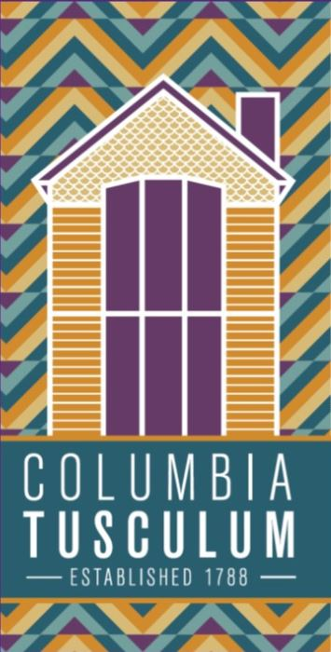
CT Community Council Meeting Agenda
April 15, 2019

Facebook: @CTCincinnati Email: ctcc@columbiatusculum.org Web: columbiatusculum.org

- Fire Update: Captain Monty (513-352-2318) – 5 min
- Police Update: Officer Butler (kevin.butler@cincinnati-oh.gov) – 5 min
- Riverview East Update: Charlene Myers – 5 min
- MSD Update: Keith Heffner – 5 min
- Treasurer Update/NSP Vote: Karl – 5 min
- Neighborhood Summit Debrief: Jonathan Hay – 5 min
- VOTE: Walworth 40 SF Home Development: TJ Ackerman – 5 min
- VOTE: Alms Park Festival $1,000 request: Matt – 5 min
- Forcht Bank artwork installation: Kelly Moran – 5 min
- Tuesday Night Tidy: Kathy Hickey – 5 min
- Tusculum Street Fest: Aaron – 5 min
- Any other business – 5 min

CT Community Council Meeting Agenda
April 15, 2019

Facebook: @CTCincinnati Email: ctcc@columbiatusculum.org Web: columbiatusculum.org

- Fire Update: Captain Monty (513-352-2318) – 5 min
- Police Update: Officer Butler (kevin.butler@cincinnati-oh.gov) – 5 min
- Riverview East Update: Charlene Myers – 5 min
- MSD Update: Keith Heffner – 5 min
- Treasurer Update/NSP Vote: Karl – 5 min
- Neighborhood Summit Debrief: Jonathan Hay – 5 min
- VOTE: Walworth 40 SF Home Development: TJ Ackerman – 5 min
- VOTE: Alms Park Festival $1,000 request: Matt – 5 min
- Forcht Bank artwork installation: Kelly Moran – 5 min
- Tuesday Night Tidy: Kathy Hickey – 5 min
- Tusculum Street Fest: Aaron – 5 min
- Any other business – 5 min

